Also suited for notice boards, cafeteria walls and company websites!

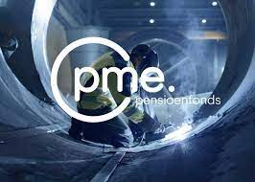

Member consultation on pensions, concept transition plan PME
All CNV members (formerly) employed in the metalektro, who have their pension (build-up) transferred to PME, have until October 25th to cast their vote on the concept transition plan. The concept transition plan has been negotiated over the course of a year and a half by FME employers and the unions. CNV members received a first message about the vote on October 2. The pension committee, composed from our collective bargaining committee, has given the plan a green light, recommending approval by members. CNV’s national framework group also greenlit the concept transition plan on September 19. However, final approval is always up to our members: a majority has to agree for the plan to become definitive. The results of the vote will be announced after October 25th. You can also read more about it on our website Akkoord concept pensioenregeling Metalektro - Nieuws | CNV Vakmensen

Collective bargaining agreement texts and collective bargaining agreement book
New collective bargaining agreement texts and collective bargaining agreement book are available. You can read and/or download the new collective bargaining agreement texts via Cao Metalektro - Metalektro | CNV Vakmensen
You can view the other collective bargaining agreements in the metalektro via the 'more downloads' button.

Click here to order a new cba book. We will ensure free delivery of the collective bargaining agreement book to the address you provide.

Economic development
In the figure below you can see we have never earned as much as we do now. Gross domestic product (GDP) represents our collective income. It stood at 97.6 in 2017 and will be 110 after the first half of 2024 (2021100), according to the figures from CBS.

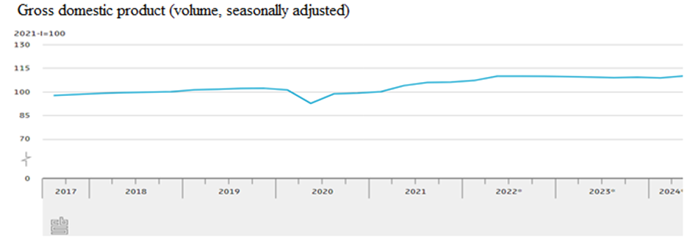

Inflation and wage development
In the figure below you can see the impact of the wage increases on inflation (blue line) in recent years. The takeaway is that wages are barely keeping up with inflation. Currently, there is a real wage increase, which means purchasing power goes up, of approximately 3%.

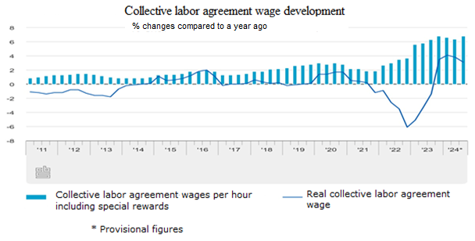

Less money to employees, more money to shareholders
In the picture below you can see profits are rising faster than incomes, meaning that less money is going to employees, and more to shareholders/owners of a company.
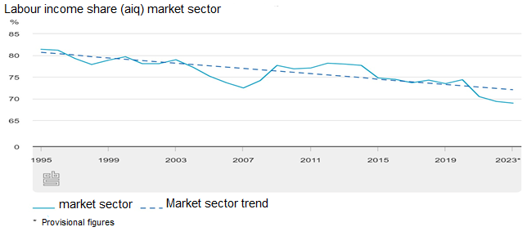
Purchase index
The purchase index shows what purchasers are doing at companies. If nothing is being purchased anymore, that indicates that the company has no orders or no money: bad news in both cases. If a lot is being purchased, there is apparently a lot to process, and money is not a problem. In the picture below you can see that more was purchased in the Netherlands this year than last year, but that this increase turned into a decrease in the summer. According to the banking sector, this will increase again in the short term due to an expected fall in interest rates. That is why entrepreneurs are keeping a tight rein on their purse strings for the time being. A score of less than 50 indicates a weak purchase market. A score higher than 50 means a strong purchasing market and more than 60 is a very strong purchasing market.
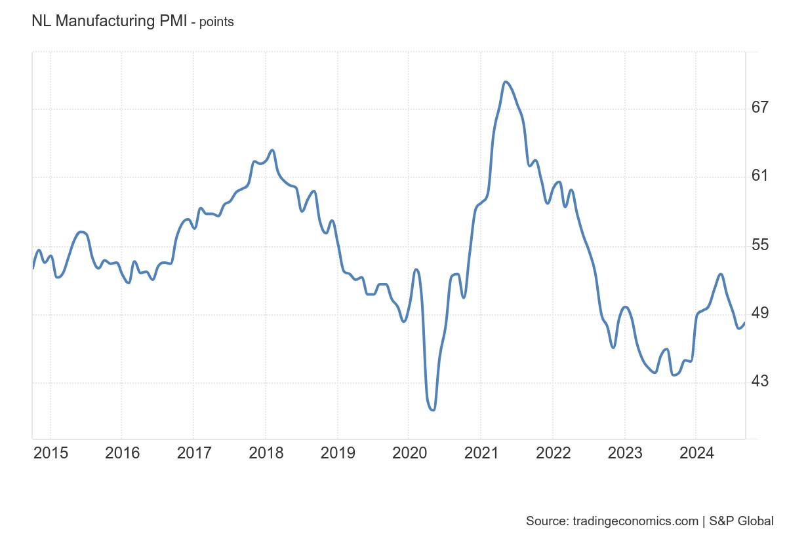

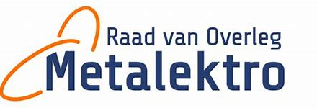

Metal and Electrical Consultation Council
Progress on the agenda of the Metal and Electrical Consultation Council (ROM)
The ROM includes representatives of employers and trade unions. As social partners, they are united in a board and mainly implement agreements made in the collective bargaining agreement consultation. However, the actual implementation is done by the people who work for the ROM as professionals. The various 'to do' points below can also be found in the various collective bargaining agreement principle agreements of the past years. Also use the information on the ROM website

The general state of affairs is as follows:
- The collective bargaining agreements were registered with the government at the end of July. The procedure for the General Binding Declaration (AVV) is ongoing. It can be expected that the collective labor agreement will now be declared generally binding at any time, meaning that the collective labor agreement applies not only to all FME members since July 19, but also to all other companies in the sector. This means that most metal and electrical employees must have received the wage increase of 1 June (2.75%).
The following wage increases are still coming up until 31 December 2025:
  - 3.25% as of 1 January 2025
  - 3% as of 1 June 2025
  - The employer compensation pension premium will stop as of 1 January 2015
- Project merge basic and hp collective bargaining agreement Jamen to merge. collective bargaining agreement is started. The aim of this is to merge collective bargaining agreements.
- a working group will also be set up to simplify the collective bargaining agreement texts in order to make the collective bargaining agreement booklet more readable.
- Continuation of RVU is on the table in The Hague with unions, employers and the government. Because the Minister of Social Affairs seems to have an ear for the views of the unions, there will be no action for the time being. In the metal and electrical industry, it has been agreed that the existing scheme will be extended by 5 years if the government extends the existing tax scheme. In the metal and electrical industry, there are now almost 1300 people who use RVU (= approx. 13% target group).
- A meeting of all parties involved will be held shortly to continue the research into the importance of the metal and electrical industry.
- An orientation is underway on possible executors of a study into the consequences of the collective labor agreement for the elderly.
- A working group will be set up that will focus more specifically on the frameworks of a so-called skills passport and the implementation of a pilot.
- A campaign will be launched with the theme 'entry and retention of women in the metal and electrical industry' and a campaign with the theme 'informal care.
- No progress has yet been reported from the consultation with the government regarding leave savings funds.
- It is estimated that approximately 4500 employees are currently using the generation pact.

Premiums for WGA Discrepancy insurance and WIA basic insurance, as agreed in the collective labor agreement
Also in 2025, the ROM will again give a discount on the premiums for the WIA Metalektro insurances. Together with Achmea, we have determined the premiums for 2025. Good news! In these times when everything is getting more expensive, we have been able to ensure together that the premiums for 2025 will not increase! These will therefore remain the same as those of 2024.
In the table below we list the premium percentages:

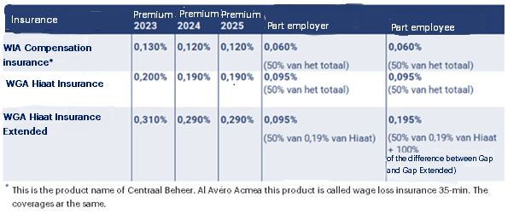

You will also receive a message from your insurer about the new premium in the short term. In addition, Achmea has adjusted the conditions in some areas. These were also explained in the letter "WIA Metalektro insurances especially for the Metalektro". WIA Metalektro insurances have been specially developed for the metalektro. So the insurances tie in well with the collective labor agreement agreements (3.8.6 en 3.8.7). And the premium is deducted from your gross salary, so it is also fiscally advantageous. Want to know more? wiametalektro.nl.

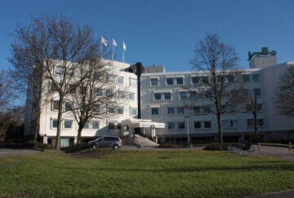
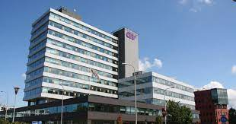

The CNV collective labor agreement committee
On September 19, we said goodbye to no fewer than 8 committee members in the collective labor agreement committee due to retirement, departure to another sector or another reason. These members are Will Kroonen, Jaap Bos, Klaas 't Hart, Hans Tempelman, Jarig Wijma, Dirk Koelewijn, Sybren Ytsma and John van Zijl.
Their years of dedication to the union on the work floor and in the committee were extensively discussed. The day was concluded informally with a pleasant dinner. This does mean that we now have a considerably lower number of committee members. This is also our appeal to interested (executive) members to consider participating in the collective labor agreement committee. According to the collective labor agreement, you will continue to be paid for the time spent on this and we will reimburse all other costs. After all, we are a union of and for members, also in the metal and electrical industry.
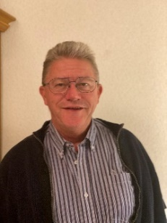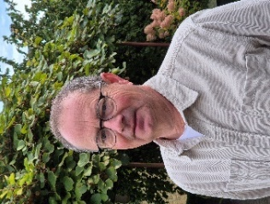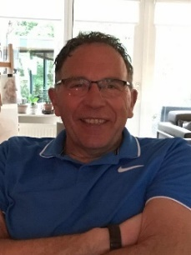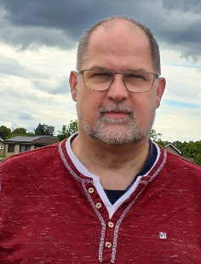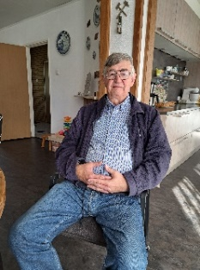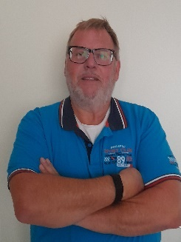
Klaas ’t Hart Will Kroonen Dirk Koelewijn John van Zijl Jarig Wijma Hans Tempelman

On October 24 and 25, 2024, the collective labor agreement committee in Niftrik will start working on the following topics:

- Functioning of the collective labor agreement committee.
- Input collective labor agreement result in the region.
- Confidentiality and Works Council
- CNV and the Metalektro project 5x Better
A good program in which all participants can definitely spend their time well! Let us know if you are interested in participating in this committee.
CNV trade union consultants in the regio

Regio | Naam | E-mail | Phone No.
Noord/Oost | Temmina Bouwknecht | t.bouwknecht@cnv.nl | 06 2219 9764
West/Midden/Zuid | Hilde Plokker | h.plokker@cnv.nl | 06 4248 9072
Noord/West | vacature

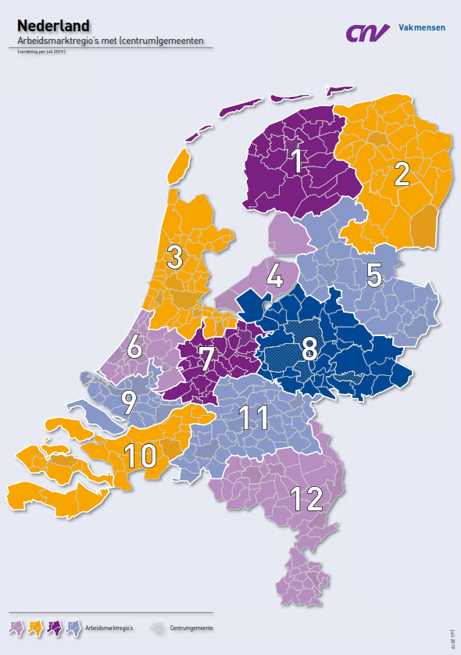

CNV-board members in the region
Below are the names and working areas of all CNV colleagues in the Metalektro

Regio | Naam | E-mailadres | Telefoonnummer
1: Friesland | Tristan Westra | t.westra@cnv.nl | +31 6 48 45 68 54
2: Groningen /  Drenthe | Tristan Westra | t.westra@cnv.nl | +31 6 48 45 68 54
3: Noord-Holland /  Amsterdam e.o. | André Mulder | a.mulder@cnv.nl | +31 6 51 60 21 45
3: Noord-Holland /  Amsterdam e.o. | Chantal van Binsbergen | c.vanbinsbergen@cnv.nl | +31 6 36 51 74 37
4: Flevopolder/  Noordoostpolder | Vacature
5: Drenthe /  Overijssel | Nicole Engmann  en  Maayke Kasper | n.engmann-vaneijbergen@cnv.nl  m.kasper@cnv.nl | +31 6 51 60 19 89  +31 6 41 63 70 49
6: Zuid-Holland | Laura Vermeulen | l.vermeulen@cnv.nl | +31 6 81 41 90 63
7: Utrecht | Juliana Jonker  en  Aron Foppen | j.jonker@cnv.nl  a.foppen@cnv.nl | +31 6 22 03 18 16  +31 6 81 91 97 19
8: Gelderland | Gerard van Dijk | g.vandijk@cnv.nl | +31 6 28 86 65 12
9: Zuid-Holland /  Rotterdam e.o. | Diana Kraan  en  Micky van Loon | d.kraan@cnv.nl  m.vanloon@cnv.nl | +31 6 22 38 95 84  +31 6 28 86 65 96
10: West-Brabant /  Zeeland | Johann Honders | j.honders@cnv.nl | +31 6 30 20 51 36
11: Oost-Brabant | Arjan Huizinga | a.huizinga@cnv.nl | +31 6 51 60 20 32
12: Limburg | Ed Leunissen | e.leunissen@cnv.nl | +31 6 29 02 32 84
ROM-bestuur | Arthur Bot  en  Tristan Westra | a.bot@cnv.nl  t.westra@cnv.nl | +31 6 20 44 51 90  +31 6 48 45 68 54
Landelijk en cao-onderhandelaar | Arthur Bot | a.bot@cnv.nl | +31 6 20 44 51 90

Finally

The information in this newsletter may give rise to questions, comments, etc. and that is fine. You can send your message to a.bot@cnv.nl
Of course, it is a good idea to distribute the newsletters on coffee tables, notice boards and ijfs websites. Make sure to copy them yourself or send an email to secretariaat@cnv.nl to have multiple copies sent to your home address.
Arthur Bot, bestuurder

